Business Question and Visualization Report

Date | 19-09-2026
Team ID | MCA
Project Title | Smartphone Usage, Digital Addiction, and Well-Being Data Analytics
Maximum Marks | 5 Marks

Visualization development in the context of this project refers to the process of creating graphical representations of mobile telemetry data to facilitate understanding, analysis, and clinical or behavioral decision-making. The goal is to transform complex datasets—such as screen time logs, notification frequencies, and pickup counts—into structured visual formats that are intuitive to interpret. This enables researchers, educators, and product designers to gain immediate insight into user habits and make informed digital wellness interventions.
Developing these visuals involves selecting appropriate graphical elements (such as donut charts for demographic splits or trend lines for late-night scrolling), design layout grids, and configuring interactive features like slicing by platform (Android vs. iOS) to enhance the end-user experience. This iterative process plays a crucial role in behavioral analytics, digital health reporting, and user-experience optimization.
Business Questions and Visualisation
The visualization process begins by defining specific behavioral business questions to guide the creation of meaningful and actionable dashboards in Power BI. Framing these questions effectively ensures the analytics engine isolates key risk metrics, captures relevant user segments, and builds interactive charts that directly solve user-overuse tendencies.
1: What is the distribution of users across different digital addiction severity tiers?
Visualization: Pie Chart showing addicted and not addicted users .

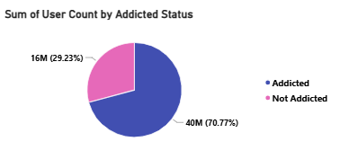

2: How do weekday vs. weekend screen time habits shift across different age groups?
Visualization: Line and clustered column chart showing weekday vs. weekend
Screen time habits shift across different age groups.
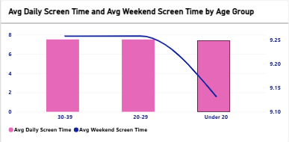

3: Which digital activities (Social Media vs. Gaming) dominate as daily screen time
rises?
Visualization: Clustered column chart showing digital activities (Social Media vs.
Gaming) dominate as daily screen time rises.

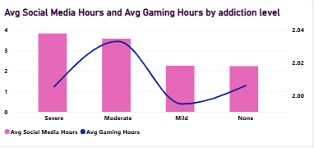

4: How does stress level correlate with compulsive checking behaviors (App Opens &
Notifications)?
Visualization: Scatter Chart showing how does stress level correlate with
compulsive checking behaviours (App Opens & Notifications) for every user-id.
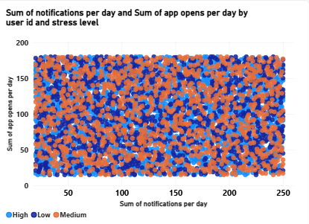

5:What is the operational impact of high screen time on student productivity and rest?
Visualization: Combo Chart showing operational impact of high screen time on student productivity and rest based on addiction level against avg work study hours and avg sleep hours.

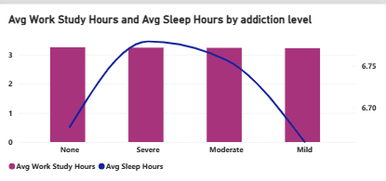

6: At what age threshold do average daily app opens and notification triggers reach their peak?
Visualization: Line Chart showing at what age threshold do average daily app opens and notifications triggers reach their peak.

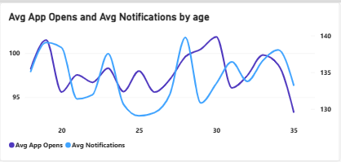

7: How do daily notification volumes accumulate and compare across different stress levels as age increases?
Visualization: Area Chart showing how daily notifications volume accumulate and compare across different stress levels as age increases.

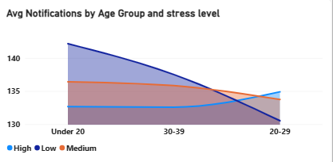

8: What is the gender breakdown among users flagged with an "Addicted Status"?
Visualization: Stacked Bar Chart showing the gender breakdown among users flagged with an "Addicted Status".

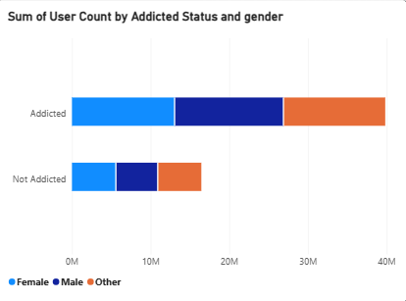

9: What is the drop-off rate of users moving from baseline smartphone use down to severe digital dependency?
Visualization: Funnel Chart showing the drop-off rate of users moving from baseline smartphone use down to severe digital dependency.

